CELEBRATE COMMEMORATE MEMORIAL DAY 2012
Co Chairs: Jane Shaffer, Sessler Companies, 315-539-3353
Dave Duprey, Waterloo Village Deputy Mayor, 315-521-9715

FOR IMMEDIATE RELEASE

FOR MORE INFORMATION:
Bill Yale, tel. 607-379-0197 or www.sampsonveteranscemetery.com
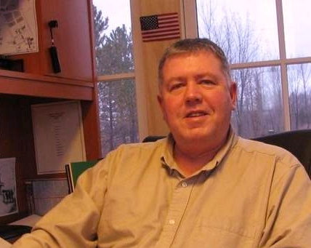

SAMPSON CEMETERY DIRECTOR
TO BE 146th MEMORIAL DAY SPEAKER
AS WATERLOO REMEMBERS

WATERLOO – Following the weekend of celebration, the Birthplace of Memorial Day pauses to remember the sacrifices of those who paid the ultimate price for freedom. The 146th solemn remembrance of Memorial Day in Waterloo will be observed on Wednesday, May 30. The Veterans of Foreign wars Post 6433 and Warner-Van Riper American Legion Post 433 will conduct the remembrance events. Memorial day is always commemorated on May 30 in Waterloo, in keeping with Gen. John A. Logan’s Order #11. The public is invited to gather at 8:30 a.m. at St. Mary’s Roman Catholic Cemetery on Stark Street for a full military service. At 10:30 a.m. marchers will leave the VFW at 29 West Elisha St. to go to Maple Grove Cemetery on Stark Street for military services at 11 a.m.
The solemn remembrance will continue at 6 p.m. when the military parade steps off from Main and Clark streets, proceeding down Main street to Lafayette Park where several veterans organizations will participate in the laying of wreaths at the veterans monuments in the park. The program will include the recitation of the Gettysburg Address and Logan’s Orders by students from Waterloo High School, the playing of the National Anthem by the high school band, and the Salute to the Dead by the VFW firing squad and the playing of Taps.
State Sen. Michael Nozzolio, William R. Yale, US Navy retired, Director of the Sampson Veterans Memorial Cemetery, and other dignitaries will speak.
Yale grew up in Honeoye Falls, and his wife, Elizabeth, is a native of Livonia, so when the opportunity came up to be the first director of the Sampson Memorial Veterans Cemetery, he jumped at the chance.
“I really appreciate the deep military history of the area, and Sampson’s Navy and Air Force history is incredible,” Yale said. “I feel a strong sense of this land.”
The Sampson Cemetery opened in July 2011, south of Sampson State Park, on land that was part of the original Sampson Naval Training Center. Since the first burial in October 2011, 56 deceased military members and spouses have been interred in the more than 100-acre site. Yale said he anticipates one or two burials per week throughout the summer.
He is a graduate of the Simmons Institute of Funeral Service in Syracuse and formerly served as a licensed funeral director in New York State, as Cemetery Representative at Bay Pines National Cemetery in St. Petersburg, Florida, and was a licensed minister and associate pastor at Kibler Road Church of God in Van Buren, Arkansas.
Yale joined the US Navy in 1977 and retired in 1999 as a first class parachute rigger. He served on the USS Nitro AE-23, and was deployed twice to the Mediterranean. He also served on the USS Nassau LHA-4 and was deployed to Beirut in 1984 and later to the Arctic Circle; the USS Tripoli LPH-10 during the Gulf War in 1991 and the USS Inchon LPH-12 for NATO North Atlantic mine-clearing operations. He also served at the helicopter anti-submarine squadron and helicopter anti-mine warfare squadron at the Naval Air Station in Norfolk, VA and Naval Air Technical Training Centers in Millington, Tenn. and Pensacola, Fla., where he served as an aviation survival equipment instructor and military training instructor
He is a member of the VFW Post 6200 of Ovid and American Legion Post 463 of Ovid.
For more information about the Sampson Cemetery, go to www.sampsonveteranscemetery.com.
The 13th annual Celebrate Commemorate event will be held May 25-30 in Waterloo, the Birthplace of Memorial Day. For more information about the events, go to www.waterloony.com.
The 146th consecutive commemoration of Memorial Day will be on Monday, May 30. It will include prayer services, and the official Memorial Day parade, coordinated by the Waterloo VFW. For more information about the solemn commemoration, contact Stan Grela at the American Legion, 1 E. William St., 315-539-8248 or Steve Twitchell, VFW, 29 West Elisha St., 315-539-9771.
#30

